**June 20, 2016 FCIA Plugfest**  
Version 0.1

1. **Physical Optical Transmitter test cases**

**1.1 Optical Modulation Amplitude**

**Purpose:**

• To verify that the Optical Modulation Amplitude of the DUT’s transmitter is within the conformance limits.

**References:**

[1] FC-PI-6 - Clause 5, Table 10

[2] FC-MSQS

[3] FC-MSQS-2

**Resource Requirements:**

• Digital oscilloscope capable of sampling a 32GFC signal at the appropriate wavelength.

• 0.5m – 5m fiber patch cord (MM).

• 2m – 5m fiber patch cord (SM).

**Discussion:**

TBD

**Test Setup:**

The DUT should be setup as defined in Appendix A. Configure the DUT for the appropriate speed. The DUT should be transitioned into the monitoring state.

**Procedure:**

***For 32GFC***

1) Instruct the DUT to begin sourcing Square Wave continuously.

2) Configure the oscilloscope to capture the waveform data.

3) Measure the OMA.

**Observable Results:**

The optical modulation amplitude, of the worst value measured, shall fall above the limits shown in Reference [1]: OMA > 0.479(-3.2)mW(dBm)

**Possible Problems:**

If the DUT supports sending random bit patterns this test should be tested by measuring the stable 1 and stable 0 levels i.e. 1111100000. If the DUT does not support a square wave pattern, the DUT will use PRBS31. If PRBS31 is unavailable, idle signaling can be used.

**2. Rise and Fall Times**

**Purpose:**

• To verify that the rise and fall times of the DUT’s transmitter are within the conformance limits.

**References:**

[1] FC-PI-5 - Clause 6

[2] FC-PI-5 - Tables 7 and 11

[3] FC-MSQS

**Resource Requirements:**

• Digital oscilloscope capable of sampling a 32GFC signal at the appropriate wavelength.

• 0.5m – 5m fiber patch cord (MM).

• 2m – 5m fiber patch cord (SM).

**Discussion:**

TBD - informational

**Test Setup:**

The DUT should be setup as defined in Appendix A. Configure the DUT for the appropriate speed. The DUT should be transitioned into the monitoring state.

**Procedure:**

***For 32GFC***

1) The Oscilloscope should be setup without any filtering.

2) Instruct the DUT to begin sourcing Square Wave continuously.

3) Configure the oscilloscope to capture the waveform data.

4) Measure the rise and fall times.

**Observable Results:**

The rise/fall times, of the worst value measured, shall be no greater than the values shown in Table ??.

**Possible Problems:**

If the DUT does not support LPB (Loop Port Bypass), or sending of the above patterns, then the

above measurements will be made with a set of continuous IDLE primitives or ARB(FF,FF) Primitives.

**3. Transmitter Eye Mask**

**Purpose:**

* To verify that the transmitter eye of the DUT is within the conformance limits.

**References:**

[1] FC-PI-5 - Clause 6

[2] FC-MSQS-2

**Resource Requirements:**

• Digital oscilloscope capable of sampling a 32GFC signal at the appropriate wavelength.

• 0.5m – 5m fiber patch cord (MM).

• 2m – 5m fiber patch cord (SM).

**Discussion:**

TBD

**Test Setup:**

The DUT should be setup as defined in Appendix A. Configure the DUT for the appropriate speed. The DUT should be transitioned into the monitoring state.

**Procedure:**

***For 32GFC***

1. Instruct the DUT to begin sourcing PRBS9 continuously.

2. Configure the oscilloscope to capture the waveform data and place these waveforms into the mask definition as defined by FC-PI-6, Clause 5.4.2, Figure 4

3. Process the captured waveform, observing the number of mask violations.

**Observable Results:**

All of the waveforms shall not violate the eye mask at any point.

**Possible Problems:**

If the DUT does not support PRBS9, the DUT shall transmit idle, and results will be marked *informative*.

1. **Physical Electrical Transmitter test cases**

## 2.1 Differential Output Voltage

**Purpose:**

* To verify that the transmitter’s differential output voltage falls within the conformance limits.

**References:**

[1] FC-PI-6 Clause 6.3

[2] Ibid., Table 13

[3] FC-MSQS-2 Clause 3

**Resource Requirements:**

* See Appendix A

**Discussion:**

Requirements for peak-to-peak differential output voltage limits are defined by reference [2]. The measurements will be taken using an oscilloscope’s peak-to-peak measurement. This to-peak measurement will provide the desired value for differential output voltage. The pattern used should be a square wave. Given the encoding scheme for 32GFC as 256/257B, which involves encoding four 64/66B words, a square wave shall consist of a 1111111100000000 (eight ones, eight zeros).

Table 2: Differential Output Voltage Requirements

|  |  |  |
| --- | --- | --- |
| Requirement | Host | Module |
| Maximum Differential Output Voltage | 900 mV | 900 mV |

**Test Setup:**

* For Host devices, see Appendix B.1
* For Modules, see Appendix B.2

**Procedure:**

1. Configure the oscilloscope to record a waveform.
2. Instruct the DUT to source square wave.
3. Capture the waveform data on the oscilloscope.

**Observable Results:**

The eye diagram measured from the transmitter should provide measurements that fall within the conformance limits provided above in Table 4.

**Possible Problems:**

If the DUT does not support sending the patterns above, the above measurements will be made with scrambled idle. The results will be marked INFORMATIVE only.

## 2.2 Rise and Fall Times

**Purpose:**

* To verify the transmitter’s transition between logic levels (using 20% and 80% of signal as delimiters) falls within the conformance limits.

**References:**

[1] FC-PI-6 Clause 6.3

[2] Ibid., Table 13

[3] FC-MSQS-2 Clause 3

**Resource Requirements:**

* See Appendix A

**Discussion:**

This test verifies that the rise and fall times of the signal are at least those defined by reference [2]. Rise and fall times for Fibre Channel technologies are defined by the transition between 20% and 80% of the mean values for logic one and logic zero. Reference [3] defines patterns used by 32GFC for certain test conditions. While source transition testing does not have a pattern explicitly designated to it by reference [3], similar tests are defined using an alternating 0101 pattern. For the purposes of this test, a clock pattern, 0101, will be used.

Table 3: Minimum Rise and Fall Times

|  |  |  |
| --- | --- | --- |
| Requirements | Host | Modules |
| Minimum Transition Time (20%-80%) | 10 ps | 9.5 ps |

**Test Setup:**

* For Host devices, see Appendix B.1
* For Modules, see Appendix B.2

**Procedure:**

1. Configure the oscilloscope to record an eye diagram.
2. Instruct the DUT to transmit 0101 continuously.
3. Capture the waveform data on the oscilloscope.
4. Measure the rise time and fall time, separately, from 20% and 80% of the mean values of logic one and logic zero.
5. Repeat steps two through four using square wave.

**Observable Results:**

The values obtained shall meet the requirements in Table 6.

**Possible Problems:**

If the DUT does not support sending the patterns above, the above measurements will be made with scrambled idle. The results will be marked INFORMATIVE only.

**3.3 Eye Height and Width**

**Purpose:**

* To verify that the height and width of the transmitted electrical signal’s eye diagram falls within the conformance limits.

**References:**

[1] FC-PI-6 Clause 6.3

[2] Ibid., Table 13

[3] FC-MSQS-2 Clause 3

[4] Ibid., Figure 3.12

**Resource Requirements:**

* See Appendix A

**Discussion:**

The transmitter pulse shape characteristics are specified through analysis of the transmitter eye diagram, shown in reference [3]. Specifications given for signal quality are given in terms of Eye Height and Eye Width, and those limits are provided in reference [2]. Specific test procedures and further description of the test methods are given by reference [3]. Test patterns to be used to measure the Eye Height and Eye Width for 32GFC are provided by reference [3]. Once the waveforms are captured, normalized cumulative distribution functions of the signals are constructed to a probability of ${10}^{-6}$. Reference [4] provides the following diagram to define the measurement points for both EH6 and EW6.

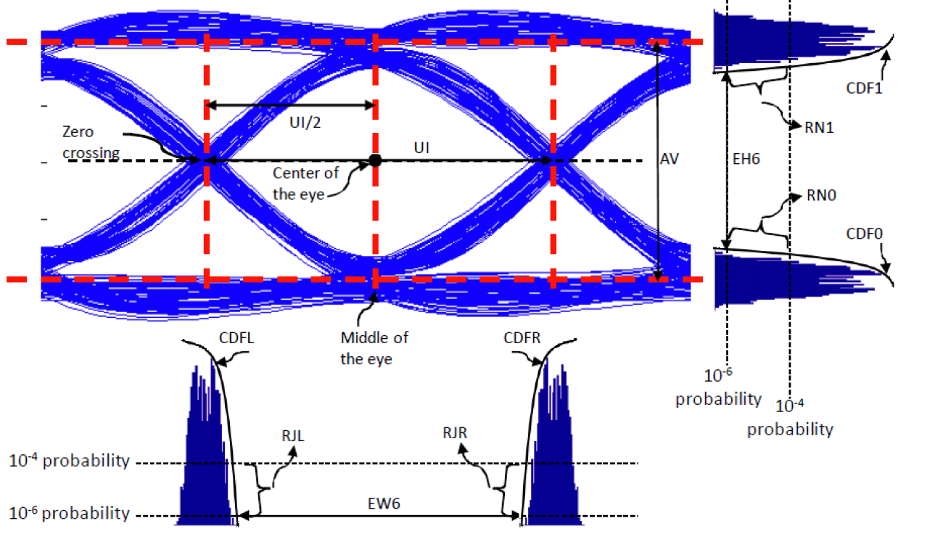

Figure 1: Eye Height and Width Measurement Points

Once EH6 and EW6 are calculated, those values must fall within the following values:

Table 4: Eye Height and Width Measurement Requirements

|  |  |  |
| --- | --- | --- |
| Requirement | Host | Module |
| Eye Width (EW6) | > 0.46 UI | > 0.65 UI |
| Eye Height (EH6) | > 50 mV | > 250 mV |

**Test Setup:**

* For Host devices, see Appendix B.1
* For Modules, see Appendix B.2

**Procedure:**

1. Configure the Oscilloscope to record an eye diagram.
2. Instruct the DUT to source PRBS9.
3. Capture the waveform data and measure the eye height and eye width of the signal.

**Observable Results:**

The eye diagram measured from the transmitter should provide measurements that fall within the conformance limits provided above in Table 2.

**Possible Problems:**

If the DUT does not support sending the patterns above, the above measurements will be made with scrambled idle. The results will be marked INFORMATIVE only.

**Appendix A(needs to be revised)**